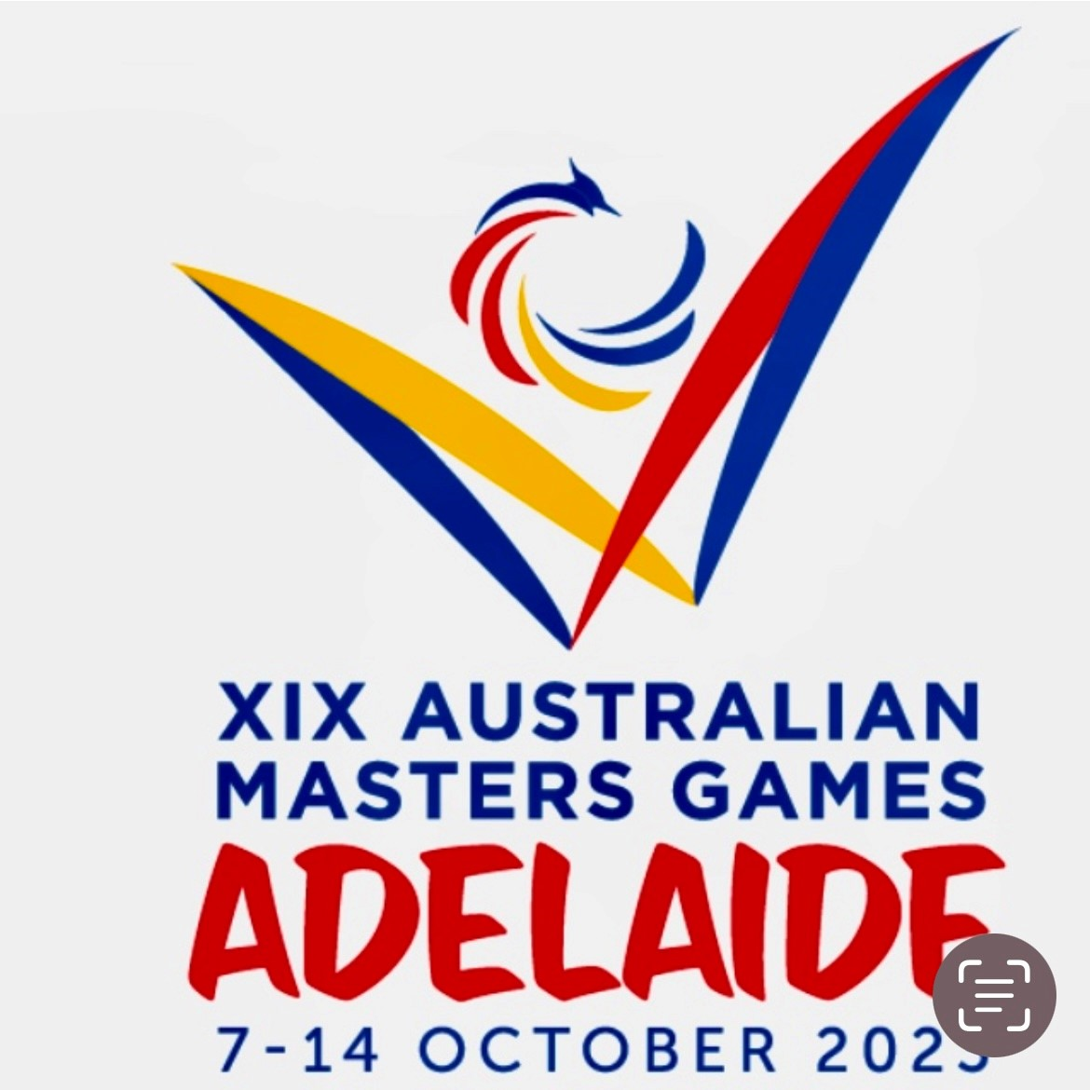
19th AUSTRALIAN MASTERS GAMES October 7th - 10th 2023 Golf Croquet Singles and Doubles North Adelaide Croquet Club Menzies Crescent, Prospect
AUSTRALIAN MASTERS GAMES CROQUET ORGANISING COMMITTEE Robin Golding (Convenor) Noel Spooner, Kevin Le Poidevin, Lynn Hughes, Chris Dalzell, Evelin Dalzell, Gayle Searle
TOURNAMENT CONTACT Croquet Convenor Robin Golding 0412 884 499
RESULTS Continuous results will be available on the web each day at GC Australian Masters Games (no handicap cards) - Croquet Scores
ACKNOWLEDGEMENTS Croquet SA acknowledge the assistance of North Adelaide Croquet Club for allowing the Australian Masters Games to use their facilities.and, also, the many NACC members as well as some from other clubs’ members who volunteered their time. Without them all this event could not be held.

Croquet is a harassment free sport. Croquet SA’s Member Protection Policy applies to all competitors and officials in the Masters Games. Information is available on the Croquet SA website www.sacroquet.com.au

GENERAL INFORMATION
Registration
Players may check-in at NACC (with their accreditation from AMG in hand) on Friday 6th October 3-5pm or from Saturday 7th Oct 8am. Players must check-in before the start of their first game.

Practice Sessions
The lawns will be available for practice Fri 3-5pm, each morning until 15 mins before the scheduled start time and, at the discretion of the Manager, may be available at conclusion of the day’s play.
Social Activity

A 2-course meal will be held at NACC Tuesday 10th October 2023 for competitors, supporters, volunteers and NACC Club Members. Cost $25-00 per person. (See flyer at end of this programme for details.) NACC members’ dinner price is $15pp.

Presentation
The Medal Ceremony will be held Tuesday October 10th to present the awards for the tournaments.

Catering
Light lunches including, soup, sandwiches, salad plates will be available for purchase by ordering before 10am each day.
$10 payment at the beginning of the tournament will allow tea/coffee and small snack anytime.
Soft drinks will be available for purchase.

Results
Results will be available on the Croquet Scores website progressively during each day:
GC Australian Masters Games (no handicap cards) - Croquet Scores

CONDITIONS OF PLAY
CONDITIONS OF PLAY GENERAL
- In keeping with the Australian Masters Games ethos that the games are open to all, with the only criteria being that minimum age requirements are met, Croquet SA advises that handicap cards will NOT be used
- All games will be played at North Adelaide Croquet Club, Menzies Cres, Prospect.
- Both events will be played according to the current WCF rules for both codes and the Australian tournament regulations (WCF GC Rules 6th edition March 2022)
- Hoops will be set as near as possible to 3 11/16”. To allow for inaccuracies in gauges, balls, hoops and setting techniques, a tolerance of +/- 1/32” is allowed.
- Dawson International balls, Quadway hoops and scoring clips will be used.
- Hoops may be checked at any time on the request of the player in play. Any hoop out of specification will be reset. If a player suspects that a ball touching both uprights of a hoop simultaneously affected the outcome of a stroke just played, they are entitled to have the equipment checked and, if necessary, adjusted or replaced. If it is found that the ball does touch both uprights of that hoop on some axis, it should be remedied and then the player may elect to replay the stroke, unless the turn has ended for another reason.
- Courts will be allocated by the Manager and games will be double banked if required.
- There will be at least one Referee at the venue each day to act as required.
- Players will wear footwear which will not mark the court and provides adequate protection for themselves both on and off the court; and neat, clean attire which the Manager judges will not cause significant offence to others. A player in unsuitable clothing or footwear will be given the opportunity to dress appropriately or will not be permitted to participate in the event.
- Players must inform the Manager if they wish to leave the Tournament Venue for any reason.
- Croquet SA’s weather policy will apply. The weather policy is available on SA Croquet website www.sacroquet.com.au The Manager will decide whether play in any match should continue if the weather is deteriorating.
- The Manager may alter the program, draw and other arrangements as are necessary in order to complete the tournament in the time available. Lights may be used at the Manager’s discretion if required to achieve the schedule.
- An appeals committee as per ACA Tournament Regulations shall determine any matters that are in dispute during the course of the tournament.
- A 5 minute warm up period will be permitted before each game when hoops may only be run in a controlled fashion. This is subject to the tournament schedule and games starting on time.
- Players are requested to be at their designated court before their scheduled starting time for each match.

CONDITIONS OF PLAY FOR GOLF CROQUET DOUBLES AND SINGLES

- Handicap cards will not be used in these events
- Players are requested to be at the venue at least 15 minutes prior to the start of the game.
- All players are responsible for their own timekeeping. Timers are provided.
- Both players in singles and each pair in doubles is responsible for ensuring that the results are correctly entered on the appropriate scoresheet at the end of each game.
- Doubles will be 13-point games time limited to 1 hour. Stop on the bell.
- Singles will be 13-point games, time limited to 45 minutes. Stop on the Bell.
- No drawn games allowed. If a game is drawn when time is called, then play must continue until another hoop is scored to decide the winner.
- Clips or pegs are to be used to ensure there is no dispute over scores.
- A 5-minute hit up is allowed before each game provided that the game will start on time.
- Unless otherwise directed, the game ends on the ring of the timer bell and when all balls affected in the last stroke have come to rest.
- In double banked games the second colours commence after the second hoop has been completed by the first colours. Timers may be stopped temporarily if the game is delayed by the other game. If there is a game in progress when a second game is started, then the second game gives way regardless of the colour of the balls.
- Players are not permitted to request or receive advice from anyone except their partner in doubles games, and should not take advantage of unsolicited information or advice
- Players’ attention is drawn to Rule 16.3 of the WCF Golf Croquet Rules regarding Playing with Reasonable Despatch, and to Tournament Regulation 12 concerning responsibilities of players.
- ENJOY YOURSELVES AND HAVE FUN

North Adelaide Croquet Club invites
Australian Masters Games
Competitors and Supporters
To a Winedown Meal

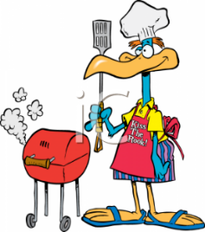
Where: NACC
Menzies Cres, Prospect
When: Tuesday 10th October

Time: 5-30pm for 6:00pm
What: Chicken, Salads and Dessert,
Tea/Coffee
Bar will be open.

Cost: $25-00 per person.

Please book for the meal at the venue
by Monday 9th October
or
email Robin Golding robingolding44@gmail.com

All Welcome

